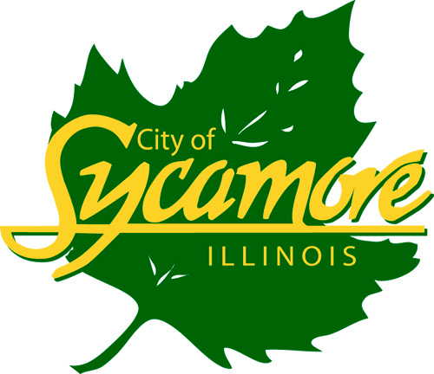

Electrical / Building Inspector, City of Sycamore

The City of Sycamore is seeking an Electrical / Building Inspector within the Building and Engineering Department. The Electrical / Building Inspector reports directly to the Director of Building and Engineering. This position is created and governed by City Code and City policies and shall comply with Federal, State and Local rules and regulations governing the position.
The position of Building / Electrical Inspector performs technical construction and other inspection work, including interpreting and enforcing structural, mechanical, electrical, and related codes, and regulations. This position also regulates new residential and commercial building construction, remodeling projects, assists in the review of building plans and specifications, and enforces all building related and property maintenance codes.
Minimum qualifications required:
- High School graduation is required.
- Supplemental education in the construction trades is preferred.
- Prior Municipal experience will receive special consideration.
- Minimum of three years of electrical experience in the construction field, including a general understanding of the building construction, electrical and mechanical trades.
- The ability to obtain and maintain all required International Code Council (ICC) certifications within eighteen (18) months of employment.
- Possession of a valid Class D State of Illinois Vehicle Operator’s license.

This is a non-exempt, full-time AFSCME Local 3957 position under the direct supervision of the Director of Building and Engineering that requires a normal 40-hour workweek. The starting annual salary is $56,620.00. The City of Sycamore offers a generous benefit package. Candidates must meet the 20-mile residency requirement within twelve months of the date of hire.
Please visit our website to view the full job description at www.cityofsycamore.com. All interested individuals should submit an application directly to the Human Resources Department. Any questions or inquiries can should be directed to Human Resources Director, Maggie Peck at 815-895-0786 or mpeck@cityofsycamore.com.
The City of Sycamore is an Equal Opportunity Employer

