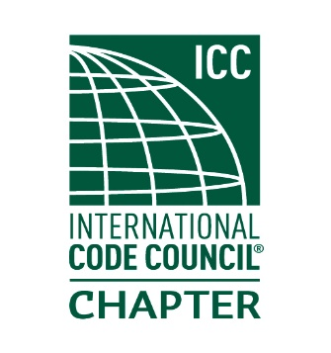
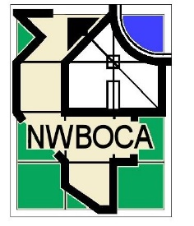
NORTHWEST BUILDING OFFICIALS AND CODE ADMINISTRATORS
NWBOCA, P.O. BOX 68611, SCHAUMBURG, IL 60193-0611
www.nwboca35.org

2018 ANNUAL NWBOCA MEMBERSHIP □ NEW □ RENEWAL

o Municipality
o Business
o Honorary (renewal fee waived)

Agency Name

Address

City State Zip

Please list primary members on this side and list secondary members on the reverse side

1. Name

2. Title

3. Phone Fax

4. Email address

1. Name

2. Title

3. Phone Fax
4. Email address

Use reverse side for additional memberships

Please complete this form and return with payment to:
N.W.B.O.C.A.
P.O. Box 68611
Schaumburg, IL 60193-0611
Primary Members (includes 2 individuals)……………$50.00
Additional members (each)……………………………..15.00 x ________
Total Amount Due……………………………………….………________

NWBOCA is a charter organization of the Illinois Council of Code Administrators (ICCA) and fully supports any legislative activity conducted by ICCA. IF your organization is against such activity which includes the financing of lobbyist, please initial here_______.

1. Name
2. Title
3. Phone/Fax
4. Email address
1. Name
2. Title
3. Phone/Fax
4. Email address
1. Name
2. Title
3. Phone/Fax
4. Email address
1. Name
2. Title
3. Phone/ Fax
4. Email address
1. Name
2. Title
3. Phone/Fax
4. Email address

