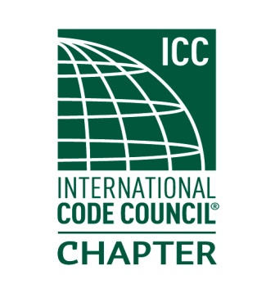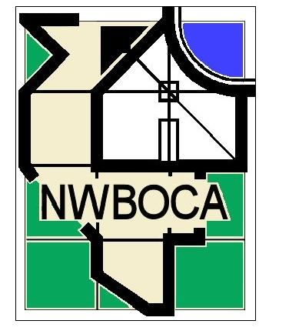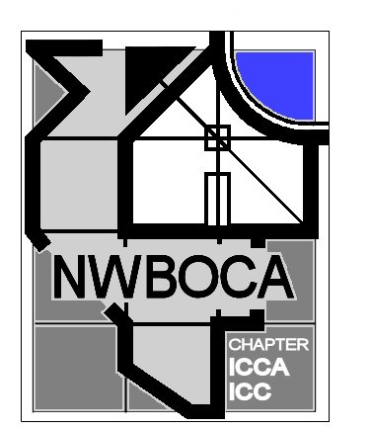19th Annual NWBOCA

# Charity Golf Outing

Help Us Help Others!

**Whisper Creek Golf Club, Huntley September 22nd 2017**

NWBOCA is an organization made up of members who represent the Building Official, Building Inspectors, and Code Enforcement Officers from municipalities in the North West region of Illinois.

Our mission is to promote the building codes, build relationships within our communities and provide continuing education opportunities for our members.

The Board of Directors is currently soliciting donations from local businesses to raise funds for our annual charitable donations. We use this event to raise funds so we can make a monetary donation to Habitat for Humanity.

**We ask that you consider helping us achieve our goals by filling one of the sponsorship roles listed below.**

**Advertising Rate Sheet**

Gold – Exclusive Sponsor – Tee Box or Green …………$200 Each

Silver – Sponsor – Tee Box or Green …………$150 Each

Bronze – Sponsor – Tee Box or Green …………$100 Each

Golf Cart Sponsor ………… $75 Each

Water Hazard Sponsor ………… $50 Each

Sand Trap Sponsor ………… $50 Each

Sponsorship in the form of gift card donations is also greatly appreciated

**For more information contact:**

Name of Sponsor (As you would like for it to appear on sign)

___________________________________________________________

Contact Person: ____________________________________

Address: __________________________________________

City-St-Zip: ________________________________________

Phone: ____________________________________________

Fax: ______________________________________________

Email: _____________________________________________

Sponsors Choice: ____________________________________

Amount Paid: ____________________

**Please make checks payable to: Northwest BOCA**

**Mail completed registration forms to: NWBOCA**

**P.O. Box 68611**

**Schaumburg, IL 60168-0611**