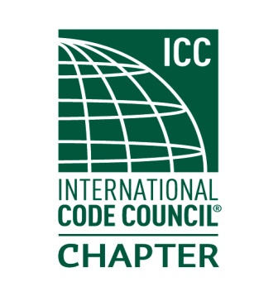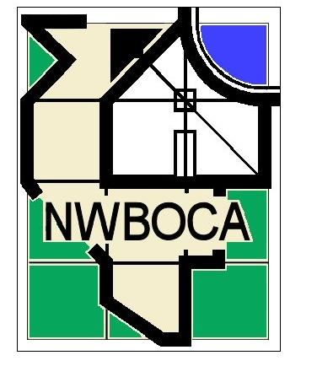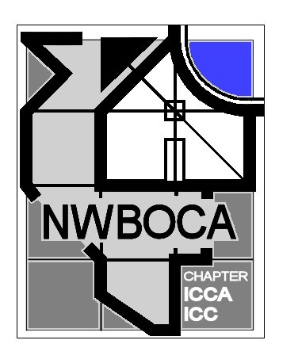19th Annual NWBOCA

# Charity Golf Outing

**In memory of Jim Wallace**

Help Us Help Others!

**Whisper Creek Golf Club, Huntley IL September 22nd 2017**

**Sign-In @ 7:30 with an 8:30 AM Shotgun Start**



$105.00 per golfer for golf, cart and lunch buffet.

($10 discount for registration before August 17th)

Golf will be played in a scramble format with prizes to be awarded for lowest team score, longest drive, closest to pin and closest to center of fairway.

A Putting contest will also be available at the end of your round.

Proceeds from this event will benefit Habitat for Humanity

$25.00 for the All American BBQ Buffet only.

-------------------------------------------------------------------------------------------------------------------

**Golfer Names:**

1) ____________________________________ 2) ______________________________________

3) ____________________________________ 4) ______________________________________

Municipality/Company: ______________________________________________________________

Number of Golfers: ___________ X $105.00 = __________ Less Discount if Applicable: ___________

Number for Lunch Only: __________ X $25.00 = __________ **Total: ____________**

**Please make checks payable to Northwest BOCA**

**Mail registration to:**

**NWBOCA**

**P.O. Box 68611**

**Schaumburg, IL 60168-0611**

**Call 847-344-7235 if you have any questions**

**Course information: www.whispercreekgolf.com**